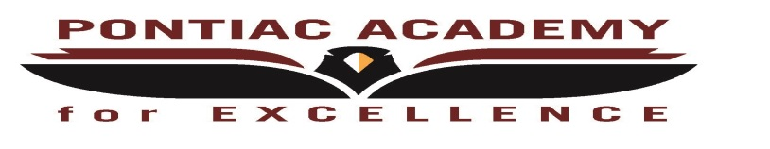
Pontiac Academy for Excellence
Extended COVID-19 Learning Plan Reconfirmation for March
Board Approved: Tuesday, May 18, 2021

Reconfirm instructional delivery method:
Pontiac Academy for Excellence’s instructional delivery is Virtual
However, we are now offering our first round of face to face in small group
sessions beginning March 1, 2021 (Monday through Thursday).
Reconfirm how instruction will be delivered for each grade level
Elementary (Grades K - 5):
Instructional delivery is virtual
We are now offering our first round of face to face in small group sessions beginning March 1, 2021 (Monday through Thursday).
Middle School (Grades 6 - 8):
Instructional delivery is virtual
We are now offering our first round of face to face in small group sessions beginning March 1, 2021 (Monday through Thursday).
High School (Grades 9 - 12):
Instructional delivery is virtual
We are now offering our first round of face to face in small group sessions beginning March 1, 2021 (Monday through Thursday).
Reconfirm whether or not the district is offering higher levels of in-person instruction for English language learners, special education students, or other special populations:
Pontiac Academy for Excellence’s instructional delivery is Virtual. However, we are now offering our first round of face to face in small group sessions beginning March 1, 2021 (Monday through Thursday).
Document Public Comments: None

Review Weekly 2-Way Interaction Rates
April 2021 | All Students K-12
Week 3 | 99.64%
Week 4 | 100%
May 2021 | All Students K-12
Week 1 | 100%
Week 2 | 99.82%

